1. What is the Namenode's URI and which file is it configured in?

Ans. Namenode's URI is hdfs://localhost:8020, it’s configured with fs.default.name property that s specified

in HADOOP_CONF_DIR/core-site.xml

2. Where on a local file system will Namenode store its image and which file is it configured in?

Ans. Namenode will store its image under /var/lib/hadoop-hdfs/cache/${user.name}/dfs/name/, it's configured

with dfs.namenode.name.dir property thats specified in $HADOOP_CONF_DIR/hdfs-site.xml

3. Where on a local file system will Datanode store its blocks and which file is it configured in?

Ans.. Datanode will store data blocks under /var/lib/hadoop-hdfs/cache/${user.name}/dfs/data/, it's configured

with dfs.datanode.data.dir property that’s specified in $HADOOP_CONF_DIR/hdfs-site.xml

4. What is the block replication and which file is it configured in?

Ans.. Replication is set to 1, it's configured with dfs replication property that’s specified in

$ HADOOP_CONF_DIR/hdfs-site.xml

Starting,creating uploading from github viewing in exerice1

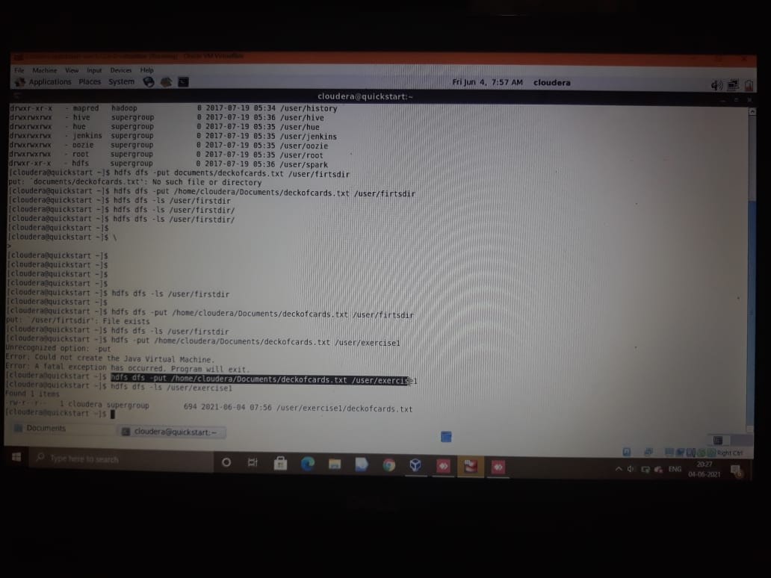

Print of first 25 lines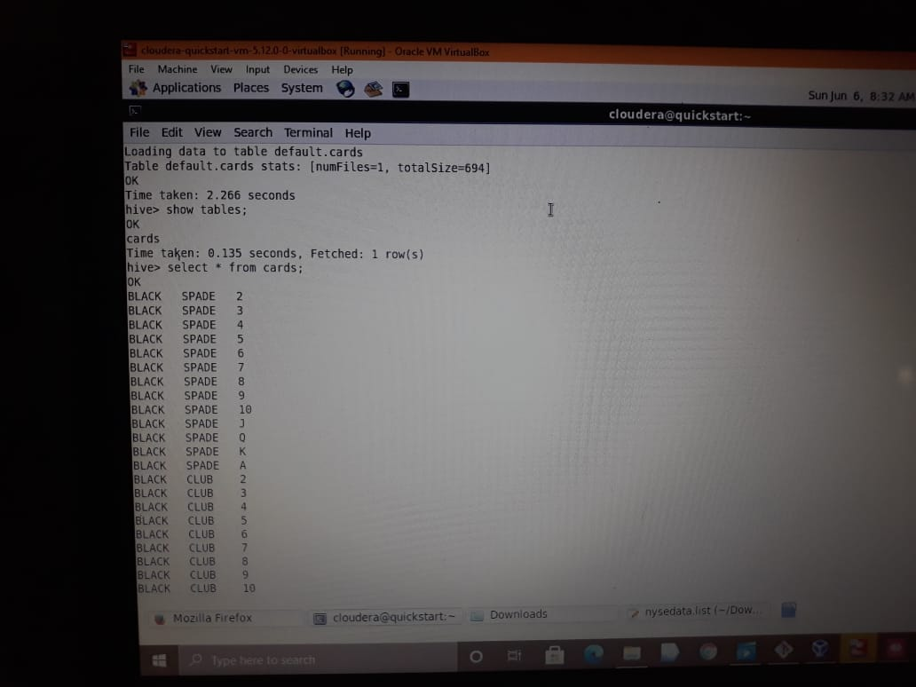

Copying and renaming it and deleting

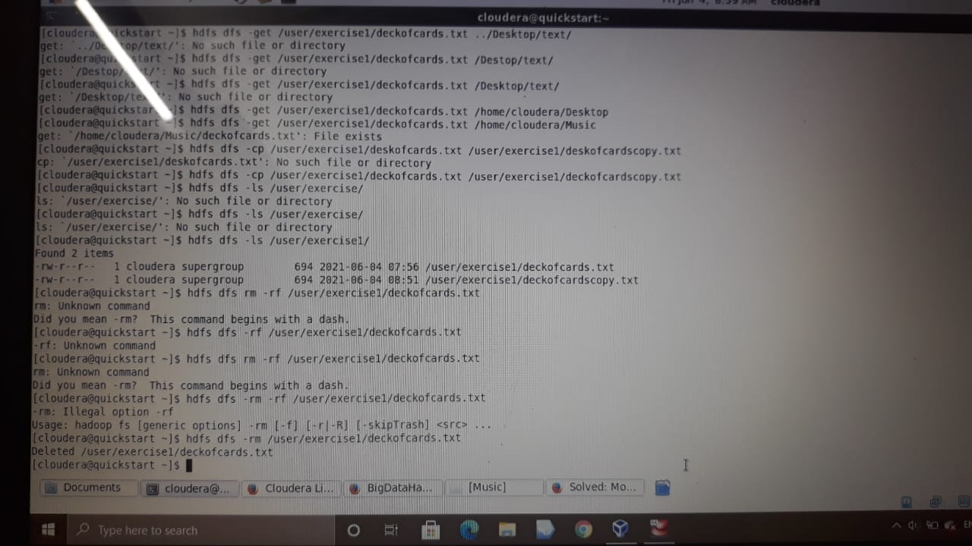

12. Take a second to look at other available shell options.

hdfs dfs -help